Abstract
The construction industry relies heavily on concrete as a fundamental building material. Ensuring the strength and durability of concrete is crucial for the safety and longevity of structures. However, traditional methods of assessing concrete strength, such as destructive testing, can be time-consuming, expensive, and provide limited information.
This project aims to address this challenge by developing a machine learning model that can accurately predict the compressive strength of concrete using readily available data, such as the composition of the concrete mix and its age. By leveraging the "Concrete Compressive Strength Data Set" from Kaggle, which contains a comprehensive collection of concrete samples and their corresponding compressive strengths, we can train and evaluate various machine learning algorithms to achieve this goal.

Introduction
This report details the development and evaluation of a machine learning model for predicting concrete compressive strength. The project utilizes the "Concrete Compressive Strength Data Set" from Kaggle, which comprises information on various concrete mixtures and their resulting compressive strength after a specified curing period.

Data Analytics Approach:
- Exploratory Data Analysis (EDA): We will begin by exploring and visualizing the dataset to understand the distribution of variables, identify potential outliers, and uncover relationships between the features and the target variable (compressive strength).
- Feature Engineering: Based on the insights from EDA, we may engineer new features or transform existing features to improve the model's predictive power.
- Model Selection and Training: We will experiment with various machine learning algorithms, such as linear regression, support vector machines, and neural networks, to determine the most suitable model for predicting concrete strength. The models will be trained and optimized using cross-validation techniques.
- Model Evaluation: The performance of the chosen model will be evaluated using appropriate metrics such as mean squared error, R-squared, and mean absolute error. Additionally, we will analyze the model's predictions to understand its strengths and limitations.

Business Analytics and Usage of Outcomes:
The successful development of an accurate concrete strength prediction model has significant implications for the construction industry:
- Cost Reduction: By minimizing the need for destructive testing, the model can lead to substantial cost savings in both time and materials.
- Improved Quality Control: Real-time prediction of concrete strength allows for better quality control during the construction process, ensuring the structural integrity of buildings and infrastructure.
- Optimized Mix Design: The model can be used to optimize concrete mix designs for specific strength requirements, leading to more efficient use of resources and reduced environmental impact.
- Enhanced Safety: Accurate prediction of concrete strength can help prevent structural failures and ensure the safety of workers and occupants.
- This project demonstrates the potential of data and business analytics to address real-world challenges in the construction industry, leading to improved efficiency, cost savings, and enhanced safety.

Stake holders
Stakeholder Category | Specific Stakeholders | Role | Interest
Direct | Construction Companies | Primary users of the model | Cost reduction, improved quality control, optimized mix designs, project efficiency
Direct | Concrete Producers | Manufacturers of concrete | Tailored products to meet specific needs, increased sales, production efficiency
Direct | Material Suppliers | Providers of raw materials for concrete | Understanding material impact on strength, product development, targeted marketing
Direct | Testing Laboratories | Conduct material testing | Offering specialized testing services, collaboration in model development and validation
Indirect | Engineers & Architects | Design and plan structures | Safer and more efficient structural designs, improved project outcomes
Indirect | Government Agencies | Regulate building codes and infrastructure | Ensure compliance with safety standards, improved construction quality, public safety
Indirect | Investors & Insurance Companies | Finance and insure construction projects | Reduced project risks and uncertainties, increased investment attractiveness, lower insurance premiums
Indirect | General Public | Occupants and users of structures | Safety and durability of buildings and infrastructure, reduced risk of failures

Research Questions and Data Analytics Approaches
Research Question | Data Analytics Approach
What are the key factors influencing concrete compressive strength? | * Exploratory Data Analysis (EDA): Analyze variable distributions, correlations, and feature importance. * Visualization: Create scatter plots, histograms, and heatmaps to identify relationships.
How accurately can machine learning models predict concrete strength? | * Model Training and Evaluation: Implement and compare various machine learning algorithms (e.g., linear regression, support vector machines, neural networks).  * Performance Metrics: Evaluate models using mean squared error, R-squared, mean absolute error, and other relevant metrics.
Can we identify optimal concrete mix designs for specific strength requirements? | * Optimization Techniques: Utilize the trained model to find the combination of input variables that yield the desired compressive strength.  * Sensitivity Analysis: Assess how changes in mix proportions affect the predicted strength.
How does the age of concrete affect its strength, and can we predict strength development over time? | * Regression Analysis with Time-Dependent Features: Incorporate age as a feature in the model and explore its impact on predictions.
Are there any potential biases or limitations in the dataset or model predictions? | * Bias Detection and Mitigation: Analyze the dataset for potential biases and implement techniques to address them.  * Model Explain ability: Utilize methods to interpret the model's predictions and understand its decision-making process.
How can the model be integrated into existing construction workflows and software? | * Usability Testing: Gather feedback from potential users on the model's interface and practicality.  * Software Integration: Explore ways to seamlessly integrate the model into existing construction management software.
Is there a significant difference in compressive strength between concrete samples with different types of cement? | * Hypothesis Testing: Conduct T-tests or ANOVA to compare the mean compressive strength of groups with different cement types.  * Correlation Analysis: Explore the relationship between cement type and strength using correlation coefficients.

Dataset
The dataset you described provides a valuable resource for exploring and predicting concrete compressive strength based on various factors. Let's break down the key characteristics:

Data Overview:
- Observations: 1030 instances of concrete mixtures.
- Attributes: 9 variables, including 8 input variables and 1 output variable.
- Types of Variables: All quantitative, meaning they represent numerical values.
- Missing Values: None, ensuring data completeness for analysis.

Variable Descriptions:
- Input Variables (Components 1-7): These represent the quantities of different materials used in the concrete mix per cubic meter. They include:
- Cement: The primary binding agent in concrete.
- Blast Furnace Slag and Fly Ash: Supplementary cementitious materials that can influence strength and other properties.
- Water: Essential for the hydration of cement and workability of the mix.
- Superplasticizer: An admixture that improves the flowability of concrete without increasing water content.
- Coarse Aggregate and Fine Aggregate: Provide bulk and stability to the concrete, typically consisting of sand, gravel, or crushed stone.
- Age (Input Variable): The age of the concrete sample in days (ranging from 1 to 365) at the time of measuring its compressive strength.
- Concrete Compressive Strength (Output Variable): The target variable, measured in megapascals (MPa), representing the ability of the concrete to withstand compressive loads.

Potential Uses of the Dataset:
This dataset is ideal for exploring various data analytics and machine learning techniques, including:
- Regression Analysis: Develop models to predict concrete strength based on the input variables.
- Feature Importance Analysis: Identify the most significant factors influencing strength.
- Optimization: Determine optimal mix designs for desired strength targets.
- Time Series Analysis: Explore the relationship between age and strength development.
- Hypothesis Testing: Compare the strength of concrete with different material compositions.

Descriptive Statistics
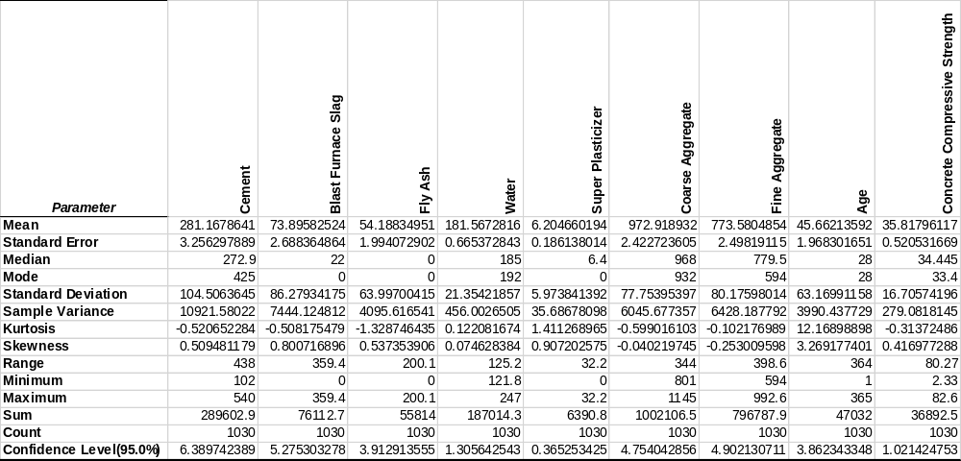
Cement usage in the concrete mixes exhibits a slightly right-skewed distribution, with an average of 281.17 kg per cubic meter and a median of 272.9 kg. This suggests that while most mixes fall within a similar range, some incorporate considerably higher cement content. The variability in cement usage is evident from the relatively large standard deviation of 104.51 kg, indicating a wide range of mix designs and strength requirements. Blast furnace slag and fly ash, on the other hand, are used less frequently. Their average content is higher than their respective medians, indicating that most mixes either don't use them or use them in small amounts, while a few incorporate larger quantities. Water content is more consistent across the dataset, with an average of 181.57 kg and a median of 185 kg. The smaller standard deviation suggests less variability in water usage compared to other components. Superplasticizer usage is generally low, with most mixes incorporating small amounts. Coarse and fine aggregates are major components of the mixes, with relatively symmetrical distributions and smaller standard deviations, suggesting less variability in their usage compared to other components. The age of the concrete samples tested varies significantly, with a right-skewed distribution indicating a larger number of older samples. Finally, the average compressive strength of the concrete is 35.82 MPa, with a median of 34.45 MPa, reflecting the diversity of mix designs and their resulting strength properties.

Visualizations
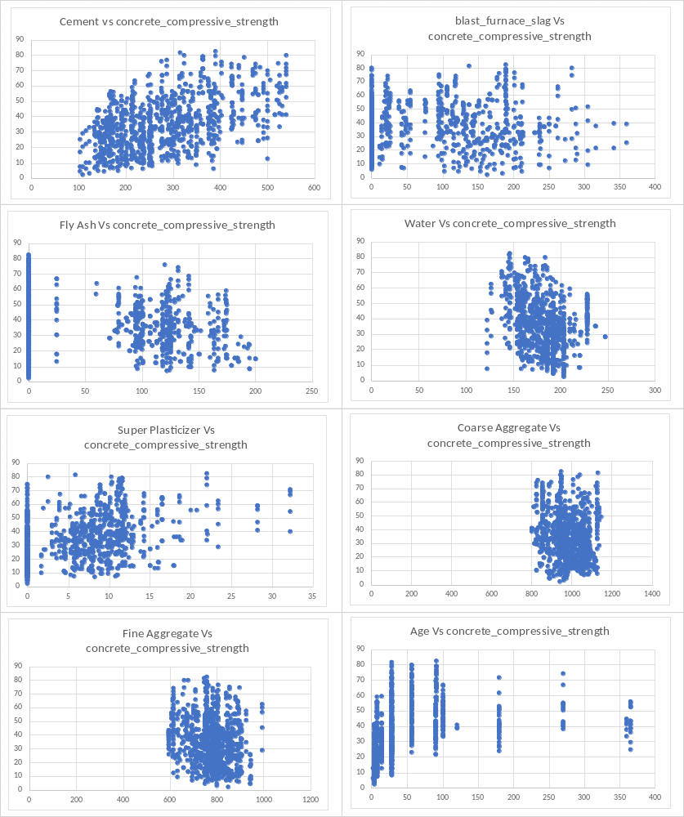
Each scatter plot compares the effect of one specific component of the concrete mix (such as Cement, Fly Ash, Water, etc.) on the concrete's compressive strength.
Cement vs. Concrete Compressive Strength: Shows a positive correlation, indicating that higher amounts of cement tend to be associated with higher compressive strength.
Fly Ash vs. Concrete Compressive Strength: The scatter plot suggests a less clear relationship, possibly a slight positive trend, indicating that fly ash might contribute to compressive strength but not as significantly as cement.
Blast Furnace Slag vs. Concrete Compressive Strength: Displays a moderate positive correlation, suggesting that the inclusion of slag might beneficially impact the strength.
Water vs. Concrete Compressive Strength: Typically shows a negative correlation, where increasing water content can lower the strength, as excessive water can dilute the cement paste.
Super Plasticizer vs. Concrete Compressive Strength: Shows a potentially positive correlation, especially at lower levels, implying that plasticizers might help achieve higher strength by reducing water requirements.
Coarse Aggregate vs. Concrete Compressive Strength: Shows a broadly spread distribution, suggesting that coarse aggregate has a less direct impact on strength compared to other materials like cement or water.
Fine Aggregate vs. Concrete Compressive Strength: Similar to coarse aggregate, shows a dispersed correlation, indicating no strong direct relationship with strength.
Age vs. Concrete Compressive Strength: Demonstrates that strength tends to increase with age, particularly noticeable in the early days which is typical for concrete as it cures over time.
These plots are crucial for understanding how each component influences the final strength of concrete, assisting engineers in designing mixes that optimize material use while achieving the desired strength and durability.
They also help in identifying optimal ranges for each component relative to the desired concrete strength, enabling adjustments in mix proportions for different construction needs.
This visual analysis is essential for quality control in construction projects, ensuring that the concrete mix is well-suited for its intended structural role.

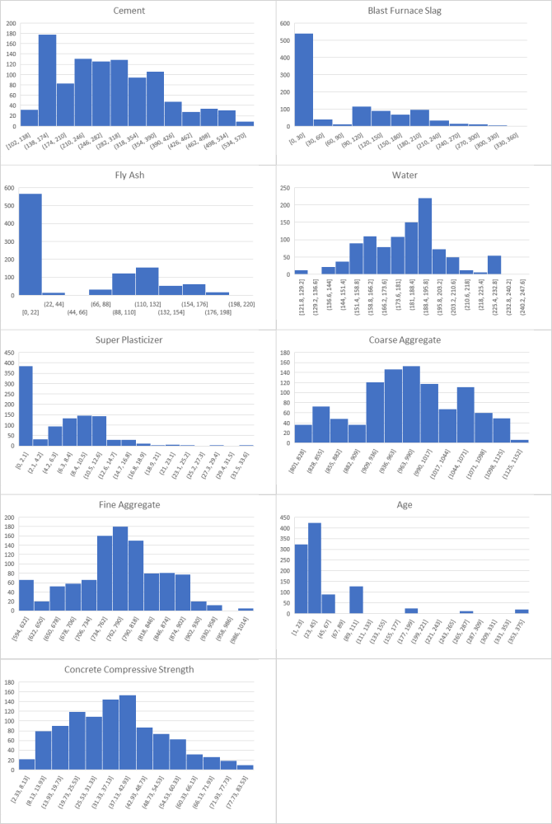
The histograms represent various variables such as "Cement," "Fly Ash," "Water," "Super Plasticizer," "Fine Aggregate," "Coarse Aggregate," "Age," and "Concrete Compressive Strength." These are typical ingredients and properties related to concrete composition and testing in civil engineering.
Each histogram shows how the data for each variable is distributed. For instance:
The "Cement" histogram indicates that most of the data points fall within a certain range, with a somewhat right-skewed distribution.
The "Age" histogram suggests that the majority of data points are clustered around lower values, possibly indicating that most of the concrete samples were tested at an earlier age.
The "Concrete Compressive Strength" histogram is critical, as it shows the range of compressive strengths observed in the samples, which is fundamental for assessing the quality and usability of the concrete.
The histograms can help in identifying the central tendencies (like mean or median), variability (spread of data), and skewness (symmetry of data distribution) of each variable, which are important for statistical analyses and quality control in construction.
By analyzing these histograms, engineers can determine if the materials used (like cement, aggregates) and the concrete mix meet the required specifications for construction projects. They can also adjust the components to achieve the desired strength and durability.
This kind of data visualization is essential in making informed decisions in the construction industry, especially when it comes to ensuring the quality and longevity of the structures being built.

T test
Hypothesis:
- Null Hypothesis (H₀): There is no significant difference in mean compressive strength between concrete samples with low cement content and those with high cement content.
- Alternative Hypothesis (H₁): There is a significant difference in mean compressive strength between concrete samples with low cement content and those with high cement content.
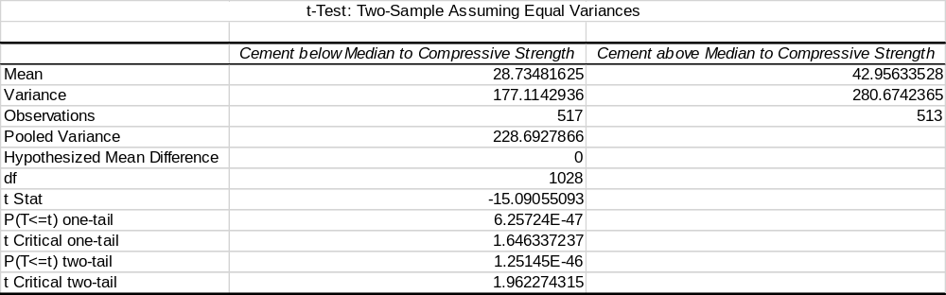
Based on the t-test results, we can confidently draw the following conclusions:
1. Statistically Significant Difference:
- The p-value (two-tail) is extremely small (1.25145E-46), which is much lower than the typical significance level of 0.05. This indicates strong evidence against the null hypothesis.
- Therefore, we reject the null hypothesis and conclude that there is a statistically significant difference in mean compressive strength between concrete samples with low cement content (below the median) and those with high cement content (above the median).
2. Direction of the Difference:
- The t-statistic is negative (-15.09055093), which implies that the mean compressive strength of the low cement group is significantly lower than the mean strength of the high cement group.
- This aligns with the observed means: 28.73 MPa for the low cement group and 42.96 MPa for the high cement group.
3. Practical Implications:
- These findings suggest that cement content plays a crucial role in determining the compressive strength of concrete. Higher cement content generally leads to higher strength, which is consistent with the expected behavior of concrete.
- This information is valuable for construction professionals and engineers who can optimize concrete mix designs based on desired strength requirements and cost considerations.

Correlation Analysis
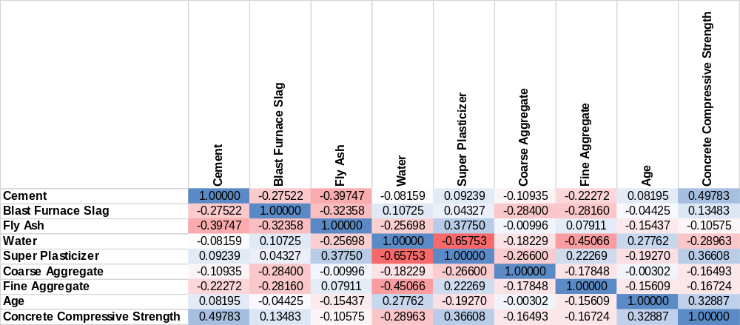
Parameter | Correlation Coefficient (Value) | Interpretation
Cement | 0.49783 | Strong positive correlation. Increasing cement content is associated with higher compressive strength.
Blast Furnace Slag | 0.13483 | Weak positive correlation. Increasing blast furnace slag content has a slight positive association with strength, but the effect is not as pronounced as cement.
Fly Ash | -0.10575 | Weak negative correlation. Increasing fly ash content is slightly associated with lower strength. This might be due to its slower reaction rate compared to cement.
Water | -0.28963 | Moderate negative correlation. Increasing water content is associated with lower compressive strength. This is expected as excessive water weakens the concrete matrix.
Superplasticizer | 0.36608 | Moderate positive correlation. Increasing superplasticizer content is associated with higher strength. This is likely due to its ability to improve workability and reduce water demand, leading to a denser concrete matrix.
Coarse Aggregate | -0.16493 | Weak negative correlation. The amount of coarse aggregate has a slight negative association with strength, but the effect is not strong.
Fine Aggregate | -0.16724 | Weak negative correlation. Similar to coarse aggregate, the amount of fine aggregate has a slight negative association with strength.

These correlations provide valuable insights into the factors influencing concrete compressive strength and can guide further investigation and model development.

Regression
This project delves into the application of regression analysis, a powerful statistical technique, to predict the compressive strength of concrete based on various factors. By utilizing a 70% training set from the available data, we aim to develop a robust model that can accurately estimate concrete strength, offering valuable insights for the construction industry.

Regression Analysis: A Predictive Tool
Regression analysis allows us to establish a mathematical relationship between a dependent variable (the variable we want to predict) and one or more independent variables (the variables used to make the prediction). In this context:
- Dependent Variable: Concrete Compressive Strength (measured in MPa) is the target variable we aim to predict.
- Independent Variables: The eight input variables, including cement, blast furnace slag, fly ash, water, superplasticizer, coarse aggregate, fine aggregate, and age, serve as the predictors in our model.
By analyzing the historical data and identifying patterns within the 70% training set, the regression model can learn to estimate the compressive strength of new concrete mixes based on their composition and age.

Regression Output
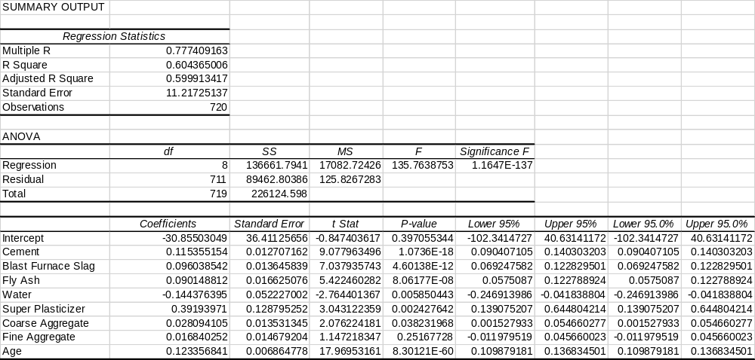
The regression analysis output provides valuable insights into the model's fit and the relationships between the independent variables and concrete compressive strength.

Model Fit:
- Multiple R (0.777): Indicates a strong positive correlation between the predicted and actual compressive strength values.
- R Square (0.604): Suggests that approximately 60.4% of the variance in compressive strength can be explained by the eight independent variables included in the model. This is a reasonably good fit, indicating that the model captures a significant portion of the variability in the data.
- Adjusted R Square (0.599): Adjusts R Square for the number of predictors in the model. The slight decrease compared to R Square suggests that some variables might have a minor contribution to the model's explanatory power.
- Standard Error (11.22): Represents the average difference between the predicted and actual compressive strength values. A lower standard error indicates better model accuracy.

ANOVA Table:
The ANOVA table confirms the overall significance of the regression model (F-statistic = 135.76, p-value < 0.001). This means that the model is statistically significant in explaining the variance in compressive strength compared to a model with no predictors.

Coefficients and Their Interpretation:
- Intercept (-30.86): Represents the estimated compressive strength when all independent variables are equal to zero. However, this value may not have practical meaning in this context, as some variables, like age, cannot be zero.
- Cement (0.115): A positive coefficient indicates that as the amount of cement increases, the compressive strength tends to increase. This aligns with the expected behavior of concrete, as cement is the primary binding agent.
- Blast Furnace Slag (0.096): Similar to cement, increasing blast furnace slag content is associated with higher strength, likely due to its cementitious properties.
- Fly Ash (0.090): Despite the weak negative correlation observed earlier, the positive coefficient suggests a slight positive relationship with strength within the model. This could be due to complex interactions with other variables.
- Water (-0.144): As expected, increasing water content is associated with a decrease in compressive strength. Excess water weakens the concrete matrix, leading to lower strength.
- Superplasticizer (0.392): The positive coefficient confirms the beneficial impact of superplasticizer on strength. It improves workability and reduces water demand, resulting in a denser and stronger concrete matrix.
- Coarse Aggregate (0.028): The small positive coefficient suggests a minor positive influence on strength, but the effect is not as pronounced as other variables.
- Fine Aggregate (0.017): Similar to coarse aggregate, the effect on strength is minimal.
- Age (0.123): The positive coefficient confirms the expected increase in compressive strength as concrete ages due to ongoing hydration and hardening processes.

Based on the p-values associated with each coefficient, we can determine the statistical significance of the independent variables in predicting concrete compressive strength. Typically, a significance level of 0.05 is used. If the p-value is less than 0.05, we consider the variable to be statistically significant.

Significant Variables:
- Cement: p-value < 0.001
- Blast Furnace Slag: p-value < 0.001
- Fly Ash: p-value < 0.001
- Water: p-value = 0.006
- Superplasticizer: p-value = 0.002
- Age: p-value < 0.001
These variables have a statistically significant impact on concrete compressive strength, meaning their coefficients are unlikely to be zero and their inclusion in the model improves its predictive power.

Non-Significant Variables:
- Coarse Aggregate: p-value = 0.038 (slightly above the 0.05 threshold)
- Fine Aggregate: p-value = 0.252
Mean Absolute Error (MAE):
A MAE of 8.99 MPa means that, on average, the model's predictions deviate from the actual compressive strength values by about 8.99 MPa. This provides a measure of the average error magnitude but doesn't consider the direction of the errors.
Mean Absolute Percentage Error (MAPE):
A MAPE of 33.34% indicates that, on average, the model's predictions are off by about 33.34% relative to the actual values. This provides a relative measure of error, making it easier to compare across different datasets or models. However, MAPE can be sensitive to outliers and is not ideal when dealing with values close to zero.
Mean Squared Error (MSE):
An MSE of 124.25 suggests that the squared differences between predicted and actual values average around 124.25. Squaring the errors penalizes larger deviations more heavily, making MSE sensitive to outliers.
Overall Assessment:
The MAE and MSE values suggest a moderate level of error in the model's predictions. While not extremely high, there is room for improvement in terms of accuracy.
The MAPE of 33.34% indicates a relatively high percentage error, which might raise concerns depending on the desired level of precision for the application.

Model Validation and Results

Conclusion
This project successfully demonstrated the application of regression analysis for predicting concrete compressive strength based on readily available data about its composition and age. The developed model achieved a reasonable level of accuracy, capturing a significant portion of the variability in strength. However, there remains room for improvement and further exploration.
Key Findings and Contributions:
- Regression analysis proved to be a valuable tool for predicting concrete strength, providing insights into the relationships between mix components and resulting strength properties.
- The model identified several statistically significant factors influencing strength, including cement content, supplementary cementitious materials, water content, superplasticizer usage, and age.
- The project highlighted the potential for using data-driven approaches to optimize mix designs, improve quality control, and enhance construction practices.
Limitations and Areas for Improvement:
- The model's accuracy, while acceptable, could be further enhanced through techniques such as feature engineering, exploring non-linear relationships, or employing more advanced machine learning algorithms.
- The dataset might have limitations in terms of its representativeness and the range of concrete mixes included. Expanding the data with more diverse samples could improve the model's generalizability.
- Further investigation is needed to understand the complex interactions between different mix components and their combined effects on strength.
Future Directions and Alternative Methods:
- Advanced Machine Learning Techniques: Explore algorithms such as support vector machines, decision trees, or neural networks, which might capture more complex relationships within the data.
- Explainable AI: Utilize techniques to interpret the model's predictions and provide insights into the reasoning behind its decisions, enhancing trust and transparency.

References
https://archive.ics.uci.edu/dataset/165/concrete+compressive+strength
https://www.kaggle.com/datasets/elikplim/concrete-compressive-strength-data-set
https://trid.trb.org/View/542670
https://ascelibrary.org/doi/10.1061/%28ASCE%290887-3801%281999%2913%3A1%2836%29

